# What are the social outcomes of climate policies?

Protocol for a systematic map

## Scope

* We aim to identify the social outcomes of climate policies, as assessed in ex-post studies of implemented measures.
* An ex-post study is one that examines existing, implemented policies. We have no methodological restrictions for the type of study (quantitative, modelling, qualitative), however we exclude the following:
  + Ex-ante scenarios of possible, not implemented, policies
  + Ex-ante assessments of proposed, not implemented, policies
* All climate policy measures that penalise fossil fuel use or reduce energy demand are considered, however, these must be implemented by political institutions at a national, regional or urban scale. We exclude the following:
  + Voluntary, corporate and NGO initiatives
  + Measures on land (i.e. agriculture, forestry, bioenergy)
  + Climate adaptation policies
  + Fuel switching policies (e.g. biomass to kerosene stoves)
  + Program-based measures, pilots and experimental studies not linked to overarching policies or institutions.
* Social outcomes broadly encompass the following:
  + Aspects of poverty alleviation and affordability, including the affordability of and access to energy services
  + The distributional (income) impacts of policies, along different gradients (social classes, geographic regions, gender)
  + Employment and jobs
  + Social and procedural justice (e.g. exclusion, democratic decision making)
* We exclude the following social outcomes from our study, in order to retain a manageable scope:
  + Health impacts (air quality, benefits of active travel, etc.)
  + Generic economic growth outcomes (e.g. social cost of carbon, ‘welfare’ impacts)

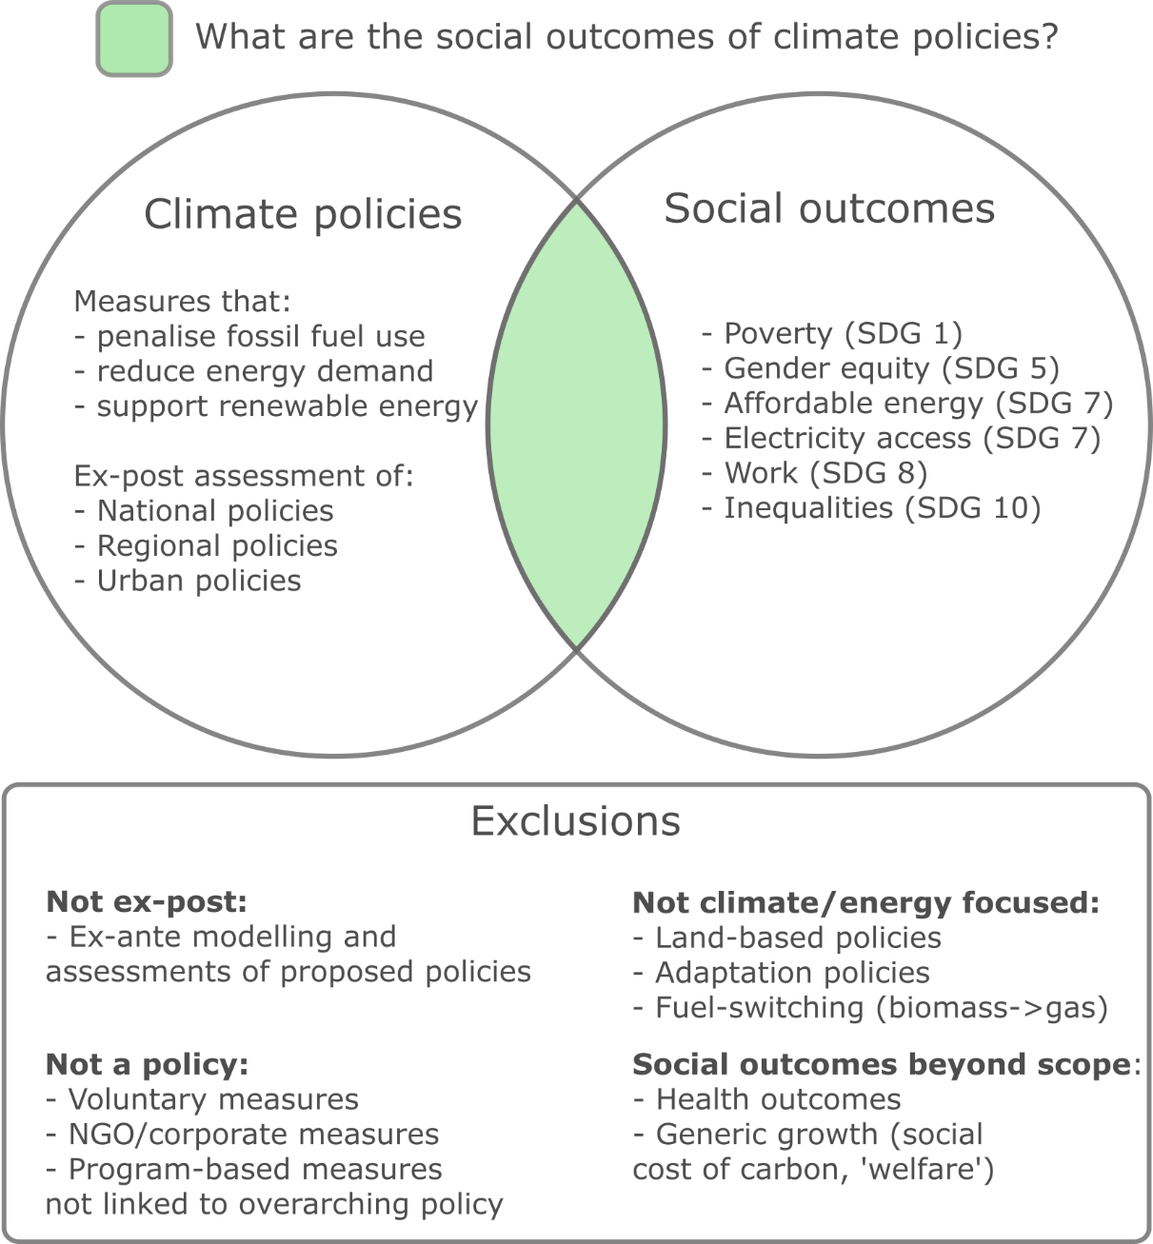

Figure 1: Scope of study

|  |  |  |
| --- | --- | --- |
|  | **Inclusion** | **Exclusion** |
| **Ex-post** | * Studies on actual implemented policies – modelling, qualitative assessments, etc. | * Studies on policies not yet implemented * Simulations of possible policies * **Ex-ante analysis of ex-post policies** |
| **Intervention type** | * Penalizes fossil fuel use * Reduces energy demand * Supports renewable energy expansion | * Land-use sector (agriculture, forestry, also migration) [also disqualifies biofuels] * Adaptation & climate impacts * Measures directed at local air pollution (e.g. NOx, SOx only) * Social policies with climate outcomes (e.g. social housing) * Energy price fluctuations with no policy intervention * Fuel switching (e.g. biomass -> LPG) |
| **Outcome type** | * Poverty and livelihoods * Affordability of services * Equity and gender * Jobs and unemployment * Inequality and distribution * Social/procedural justice * Electricity access | * Non-air quality related health * GDP, “Social cost of carbon” (aggregate economic measures) * Nutrition and hunger * Infrastructure access (water, sanitation, electricity) * Mobility * Housing and shelter * Air quality |
| **Scope of study** | * Has a statement of climate/energy policy   Led by political institutions:   * National * Regional * Urban or local   Population sample:   * Individuals, households, social groups (gendered, classed) | Let by private institutions   * Voluntary initiatives * Corporate social responsibility * Pilot studies, experiments   Population sample:   * Industries, sectors, companies |

Table 1: Summary of inclusion and exclusion criteria

## Literature Search

* We search the following databases: Web of Science, Scopus, JSTOR
* We aggregate the full list of documents and remove duplicates on the ‘APSIS Scoping Platform’ developed at MCC.
* Samples of documents will be allocated to authors and checked for coding consistency prior to full screening.
* The lead author will then screen articles, using machine learning methods to identify and re-order the documents in terms of likelihood.

## Literature Coding

* The primary information to code will be the type of policy intervention, the analysed outcome(s), and population type (e.g. households)
* Secondary information includes the effect assessment (positive, negative), study methodology, contextual information (country), and identified barriers/constraints to positive outcomes
* We will first allocate a sample of articles to authors for coding, before cross-checking for consistency. The full list of documents will then be independently coded by authors.

## Analysis

* We will report the coded information, focusing on types of policies, outcomes, and intervention locations
* We will report the assessment of the literature, in terms of positive and negative social outcomes by policy type and location, while giving a narrative summary of key issues
* We will also analyse the literature development as a whole, e.g. time trends, epistemic communities, topic analysis, key gaps

## Search query

|  |  |  |
| --- | --- | --- |
| Climate policy (intervention) | Social outcomes (outcome) | Effects |
| TS = (  ("climat*" OR  "global warming" OR  "CO2" OR  "carbon" OR  "GHG" OR  "greenhouse gas” OR  “emission*” OR  “energy” OR  “fossil fuel” OR  “renewable*”)  NEAR/3  ("tax" OR  “taxes” OR  “taxation” OR  "polic*" OR  “measure*” OR  "mitigation" OR  “abatement” OR  "reduction*" OR  “reform*” OR  “intervention*” OR  “transition*” OR  “allowance*” OR  “subsid*” OR  “pric*” OR  “tariff” OR  “program”)) | AND TS = (  “poverty” OR  “welfare” OR  “livelihood*” OR  “affordab*” OR  “justice” OR  “well-being” OR  “wellbeing” OR  “human need*” OR  “basic need*” OR  “human development” OR  “employment” OR  “unemployment” OR  “jobs” OR  “equity” OR  “gender” OR  “distribution*” OR  “inequalit*” OR  “social” OR  “socio-economic” OR  “progressive” OR  “regressive”) | AND TS = (  “incidence*” OR  “access” OR  “impact*” OR  "outcome*" OR  "effect*" OR  “burden” OR  "improv*" OR  "decline*" OR  “increase*” OR  “decrease*” OR  “benefit*” OR  “consequence*” OR  “influence*” OR  “opportunit*” OR  “performance” OR  “implication*”) |
| TS = (((("nuclear" OR "hydro*" OR "wind" OR "solar") NEAR/5 ("power" OR "energy")) OR ("solar pv" OR "hydropower"))  NEAR/3 ("tax" OR "taxes" OR "taxation" OR "polic*" OR "measure*" OR "mitigation" OR "abatement" OR "reduction*" OR "reform*" OR "intervention*" OR "transition*" OR "allowance*" OR "subsid*" OR "pric*" OR "program" OR "project" OR "deployment" OR "planning" OR "governance")) | AND TS = (  “poverty” OR  “welfare” OR  “livelihood*” OR  “affordab*” OR  “justice” OR  “well-being” OR  “wellbeing” OR  “human need*” OR  “basic need*” OR  “human development” OR  “employment” OR  “unemployment” OR  “jobs” OR  “equity” OR  “gender” OR  “distribution*” OR  “inequalit*” OR  “social” OR  “socio-economic” OR  “progressive” OR  “regressive”) | AND TS = (  “incidence*” OR  “access” OR  “impact*” OR  "outcome*" OR  "effect*" OR  “burden” OR  "improv*" OR  "decline*" OR  “increase*” OR  “decrease*” OR  “benefit*” OR  “consequence*” OR  “influence*” OR  “opportunit*” OR  “performance” OR  “implication*”) |